LINUX LAB PRACTICE ASSIGNMENT

Instructions: Try each of the following commands in question 1 (a-r)in sequence. Provide screenshot of each output after running each command. The screenshot must have explanations of the output at bottom of each screenshot explaining what you just ran and its output.

These Linux commands can run on any Linux variances. So, you are free to use any Linux variances you like. If you are still having issues downloading ‘UBUNTU’ on windows 10. You can see me for details on how to do this after class.

1. Try the following command sequence:
   1. cd
      1. 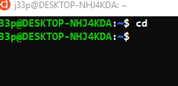
      2. The cd command changes directory. cd with nothing else will take user to the home directory.
   2. Pwd
      1. 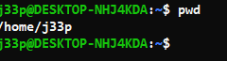
      2. This command prints the current working directory.
   3. ls -al
      1. 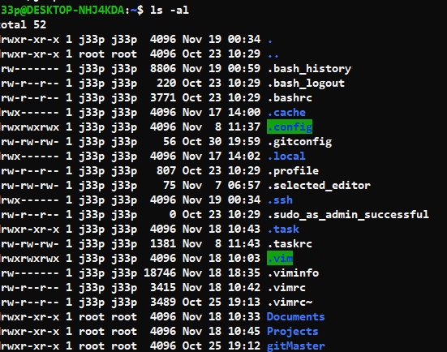
      2. Ls is list files command, adding the ‘-‘ indicates a flag which is followed by characters indicating what you would like to change.
         1. ‘a’ is allowing the ‘.’ Files to be show, these are also known as the hidden files.
         2. ‘l’ is indicating you would like the print out to be in long format, showing the extra file info, like owner, read/write/exe status and time/date of file creation.
   4. cd .
      1. 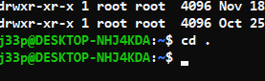
   5. pwd     (where did that get you?)
      1. Same directory ….you can see by my command prompt the ~ which indicates I’m still in my home directory …which is the same place I’ve been. This changes working directory to the current working directory
   6. cd ..
      1. 
      2. Cd .. takes you up one directory level. In my case it took me to the home dir.
   7. Pwd
      1. 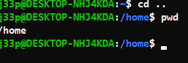
      2. Prints current working dir, which is home
   8. ls -al
      1. 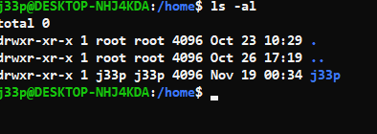
      2. Ls is list files command, adding the ‘-‘ indicates a flag which is followed by characters indicating what you would like to change.
         1. ‘a’ is allowing the ‘.’ Files to be show, these are also known as the hidden files.
         2. ‘l’ is indicating you would like the print out to be in long format, showing the extra file info, like owner, read/write/exe status and time/date of file creation.
   9. cd ..
      1. 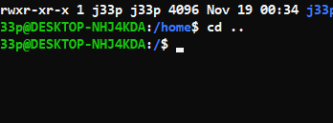
         1. Change directory up on level
   10. Pwd
       1. 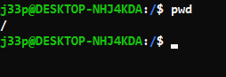
       2. Print working directory.
   11. ls -al
       1. 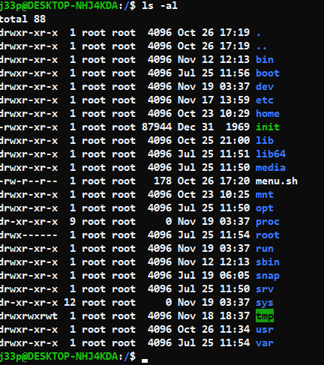
       2. Ls is list files command, adding the ‘-‘ indicates a flag which is followed by characters indicating what you would like to change.
          1. ‘a’ is allowing the ‘.’ Files to be show, these are also known as the hidden files.
          2. ‘l’ is indicating you would like the print out to be in long format, showing the extra file info, like owner, read/write/exe status and time/date of file creation.
   12. cd ..
       1. 
       2. Change directory up a level.
   13. pwd     (what happens now)
       1. 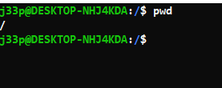
       2. We are at the root of the file system or “/”... The entire linux file system.
   14. cd /etc
       1. 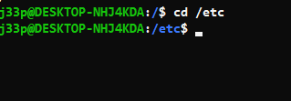
       2. Change directory to the /etc directory
   15. ls -al | more
       1. 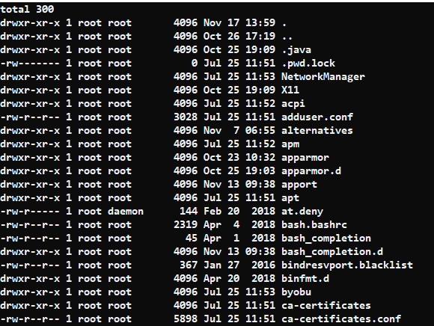
       2. This prints out the contents of the directory, the more commands loads the entire output.
   16. cat passwd
       1. 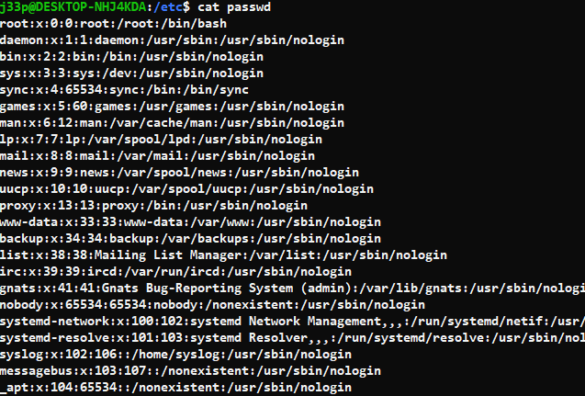
       2. Prints passwords stored on the machine and the various files associated with the passwords.
   17. cd –
       1. 
       2. Moves me up one directory level.
   18. Pwd
       1. 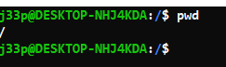
       2. Prints working directory.
2. Continue to explore the filesystem tree using cd, ls, pwd and cat. Look in /bin, /usr/bin, /sbin, /tmp and /boot. What do you see? List what you saw or actions output for each command
   * 1. 
        1. Moves me to the /bin directory.
     2. 
     3. 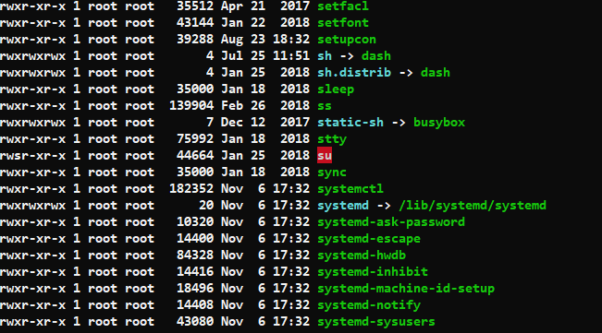
        1. Ls -al prints the contents of the directory.
     4. 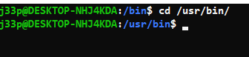
        1. Cd /usr/bin moves me to the /usr/bin directory.
     5. 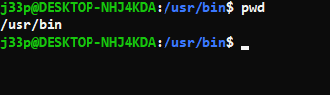
        1. Using the pwd command to show the full path of the current working directory.
     6. 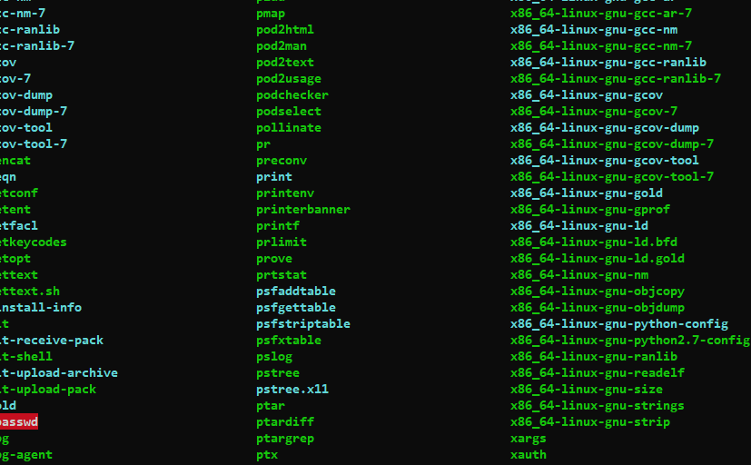
        1. Ran ls command to print the short form of the list command for the /usr/bin folder.
     7. 
        1. Change directory to /sbin
     8. 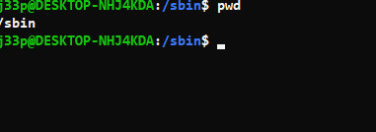
        1. Using the pwd command to show the full path of the current working directory.
     9. 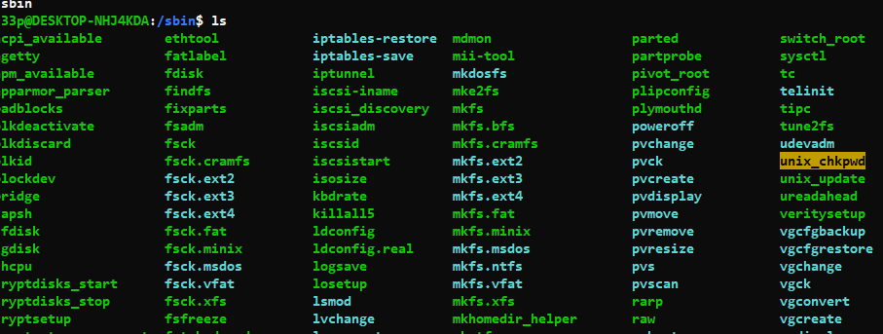
        1. Ls shows the files in this directory.
     10. 
         1. Change directory to the /tmp directory.
     11. 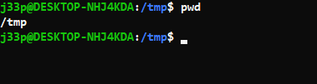
         1. Using the pwd command to show the full path of the current working directory.
     12. 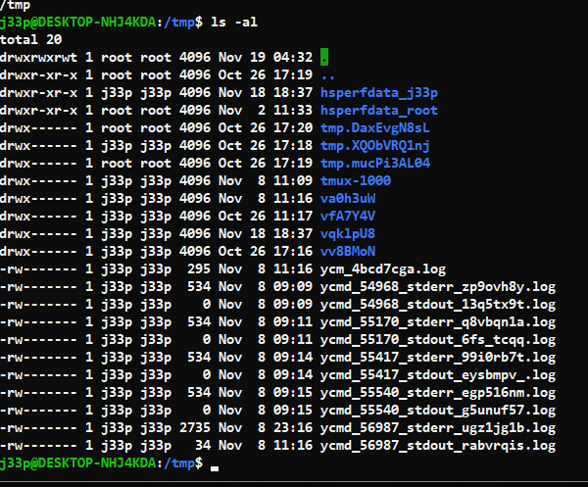
         1. Using the ls -al command to list all files and directories inside the /tmp directory.
     13. 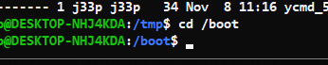
         1. Change directory to the /boot directory.
     14. 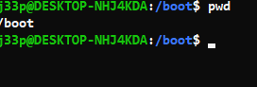
         1. Using the pwd command to show the full path of the current working directory.
     15. 
         1. Ls to show directory contents…this is my windows linux subsystem, so I do not have anything in this directory.
3. Explore /dev. Can you identify what devices are available? Which are character-oriented, and which are block-oriented? Can you identify your tty (terminal) device (typing who am i might help); who is the owner of your tty (use ls -l)? Well if no device, let me know and provide screenshot saying so. What is the name of the tty showing? Share all screenshot for each command.
   * 1. 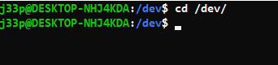
        1. Cd /dev moves us to the /dev directory.
     2. 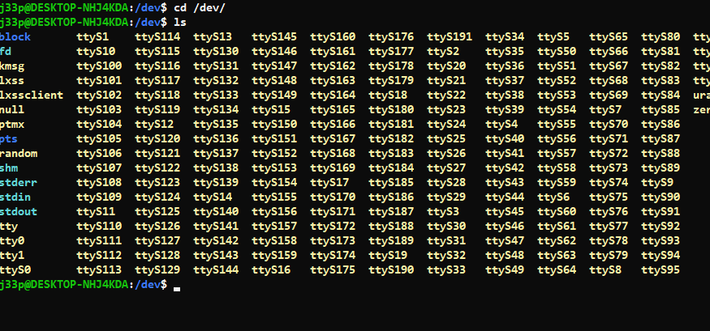
        1. Using the ls command to show files inside the /dev directory.
     3. 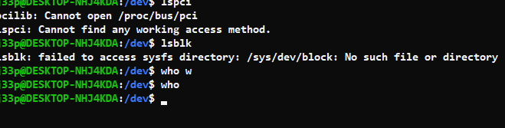
        1. Please note that because im on the windows linux subsystem, theses specific files produced no output… if I was on an actual computer these would be populated.
4. Make subdirectories called work and play.
   * 1. 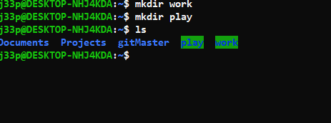
        1. Use the mkdir command to make directories work and play, then use the ls command to output the contents of directory.
5. Create list of any content into each sub-directory
   * 1. 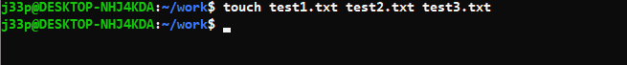
        1. Using touch command I created empty files named test.txt
     2. 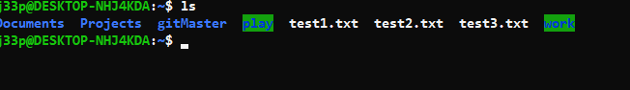
        1. Showing contents of the directory using the ls command
6. Copy content of one directory into the other
   * 1. 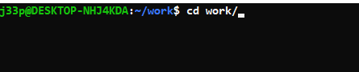
        1. Cd to the work directory.
     2. 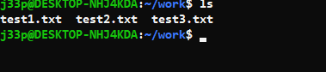
        1. List files in directory using the ls command
     3. 
        1. Copy all the files ending in .txt to the play directory. The ../play means move up a directory and then the play directory.
7. What is the difference between listing the contents of directory play with ls -l and ls -L? Explain
   * 1. 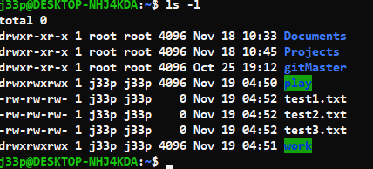
        1. Using the ls -l command inside the home subdirectory which uses long listing format.
     2. 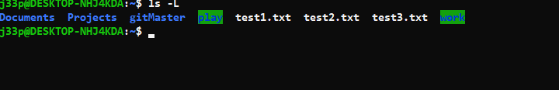
        1. Using the ls -L command inside the home directory which will show file info for a symbolic link.
8. Create a file called hello.txt that contains the words "hello world". Can you use "cp" using "terminal" as the source file to achieve the same effect? Explain.
   * 1. 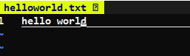
        1. Using Vim I created a helloworld.txt file with the words “Hello World” in its contents.
     2. 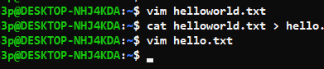
        1. Using cat “FILENAME” and > this will output the contents of the file and overwrite the new file with is contents. “>>” will append to the bottom of the file.
9. Copy hello.txt to terminal. What happens?
   * 1. 
        1. Output of the text from inside the file.
10. Imagine you were working on a system and someone accidentally deleted the ls command (/bin/ls). How could you get a list of the files in the current directory? Try it.
    * 1. 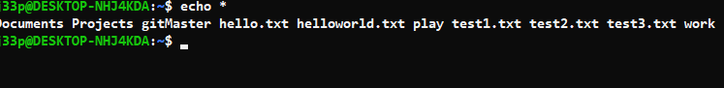
         1. Echo * will show all of the files inside the directory. This star is a terminal shortcut for all files.
11. How would you create and then delete a file called "$SHELL"? Try it. Show screenshot
    * 1. 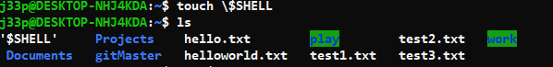
         1. Using touch you can create a $SHELL file
      2. 
         1. Removing the \$SHELL by using the rm command.
12. How would you create and then delete a file that begins with the symbol #? Try it. Show screenshot
    * + 1. 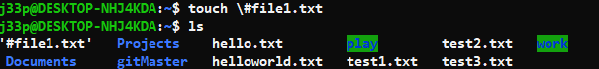
           1. Creating #file1.txt with the touch command.
        2. 
           1. Removing the file #file1.txt
13. How would you create and then delete a file that begins with the symbol -? Try it. Show screenshot
    * 1. 
         1. Creating file -file1.txt with the touch command.
      2. 
14. Experiment with the options on the ls command. What do the d, i, R and F options do? Provide content or output
    * 1. 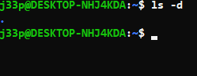
         1. Using the ls -d command lists directory entries instead of contents, will not show symbolic links.
      2. 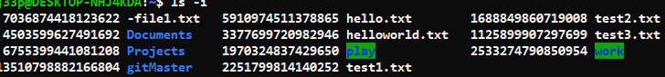
         1. Using the **ls -i** command prints the index number of each file.
      3. 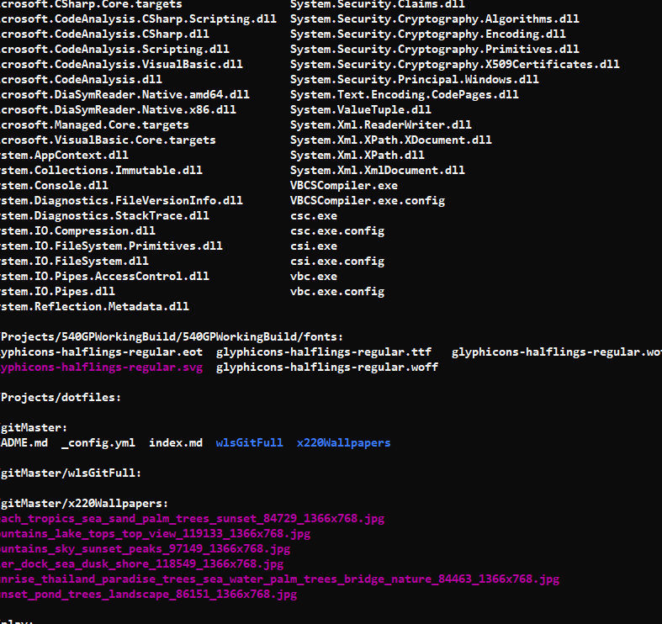
         1. Using the **ls -R** command lists subdirectories recursively.
      4. 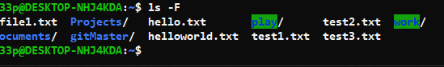
         1. Using the ls -F command adds the ‘/’ character at the end of each directory.
15. What is the output of the command: echo {con,pre}{sent,fer}{s,ed}? Now, from your home directory, copy /etc/passwd and /etc/group into your home directory in one command given that you can only type /etc once.